Accidental Explosion kills war hero!
A Hero, Lost.
By #6269 Nathan Arcuri
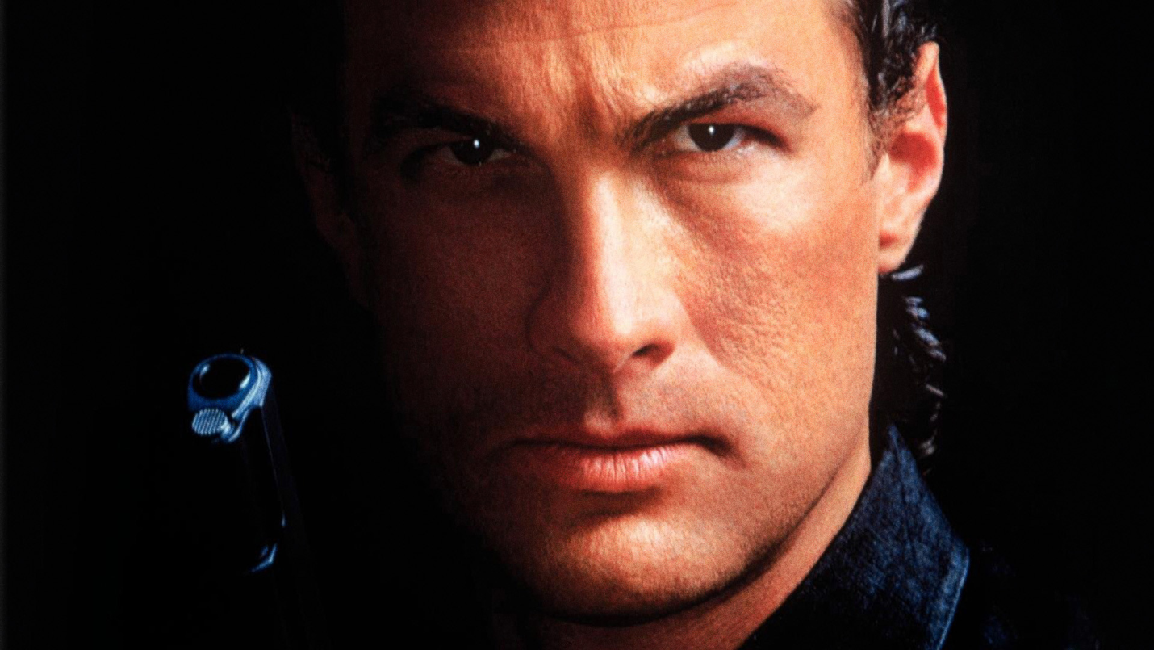
Yesterday, at 2 p.m., a hero was killed in action. Gino Felino was deploying a satchel charge in a building to complete his objective of destruction. The satchel charge exploded prematurely and his body burst into a million bits of flesh and guts. His blood sprayed against the wall and spelled “I LOVE BIG BROTHER”. Then the main support beam for the building also exploded into rubble and the building collapsed on Gino’s, unrecognizable, scattered remains. Gino was a role model for everyone and he will be missed. May Gino rest in peace forever loving Big Brother.
As a child, Gino was already a member of the Thought Police turning people in left and right. He turned in both of his parents for obtaining black market goods for him. During the physical jerks, Gino would go above and beyond. Over time, Gino became a self taught martial artist. Gino soon joined the war effort against Eastasia and had single handedly taken on waves of Eastasian soldiers, and won. Gino was awarded several Merits and Honor badges for his bravery, but he melted down the badges into bullets, instead, and used them to kill his enemies in the name of Big Brother.
Gino also signed up to test Room 101. Gino feared nothing, so they started with rats. As the rats came at his face biting and scratching, he ate them. Gino was a battle hardened sack of muscle and perfection. Gino was last man standing in a desert battle, and because he was the last man, he had to make his way back home by himself. At night he would use the peeling skin from his sun burn as a tent, sewing each piece together with his incredibly strong black hair. He made his way back home through the desert and when he was asked what he ate to stay alive, he told part members that he filter fed on air bacteria for a week.
Gino’s life was a perfect example of how we should all be. His doubleplusgood example of unconditional love for Big Brother has been an inspiration for all party members. Gino leaves behind nine children, which he obtained from artsem and trained to be thought police. Hopefully when they are of age, Big Brother will have nine more Gino’s to add to the war effort. Gino’s service will be held tomorrow in victory square, his coffin will contain a model of his corpse made purely of dead chipmunks, because his body was disintegrated, and he loved chipmunks. He thought they were adorable. BB!

